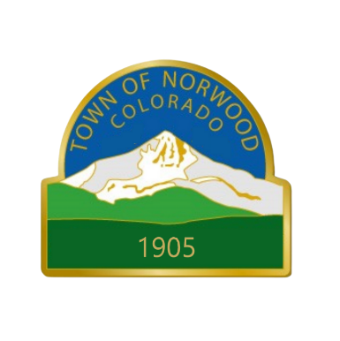

NORWOOD MUNICIPAL

COURT DOCKET

Municipal Court located at 1670 Naturita Street, Norwood, CO 81423

Courts phone number is 970-327-4288
Zoom: https://us02web.zoom.us/j/87652214503
Meeting ID - 876 5221 4503

Docket for court on

July 2, 2025, starting at 9:00am

MATEO LUCAS- SEBASTAIN– Advisement of Rights
- Citation Number: S25-0097 – Public Intoxication

DAHNDRAY, BENO– Advisement of Rights
- Citation Number: S25-0221– Public Intoxication and Disorderly Conduct

ANDREW BASS– Court Trial
- Citation Number: S25-0116 – Public Intoxication

